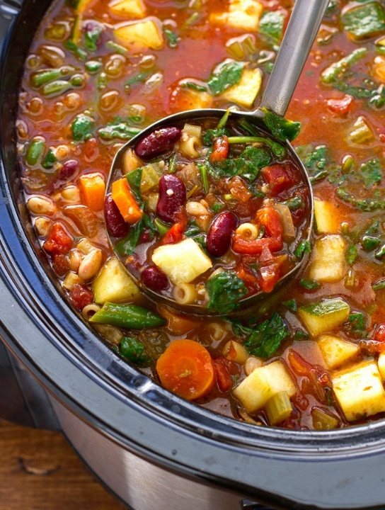

-CYM High School Youth Group hosts-
Soup and Chili Challenge!
Join us for Fun & Fellowship!
Sunday, November 17th, 2024
11:30am-1:00pm
St. Mary Catholic School Gym
Come and enjoy a free lunch of soup and chili! We will also have a Live Dessert Auction featuring delicious desserts made by the high schoolers and a 50/50 Raffle.
COME JOIN IN THE FUN!
Do you have a delicious soup or chili recipe? We need you to join in the competition! Attendees will vote for their favorite, and the "Overall Winner" will receive a prize.
To register your entry contact Carrie Weber 316-215-2551.

