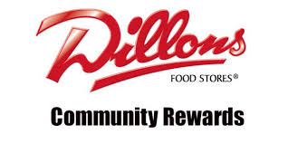
The Dillons Community Rewards program donates a certain percentage of your purchases to a local charity of your choosing. What you buy at Dillons can benefit St. Mary’s with no additional cost to you.

How to sign up for Dillons Community Rewards
- Create a digital account if you haven’t already
  - https://www.dillons.com/rx/account/create
- Now simply link your shopper’s card or alternate ID to your digital account
- Once logged into your account, click on “Community Rewards” and provide your personal info.
- Next, in the “Find your Organization” space, search St Mary Catholic Church and click on it
- Don’t forget to scroll down and click on “Enroll”

Below is a link to a video that explains how sign up:

https://www.youtube.com/watch?v=ct4YSyxm5-4

