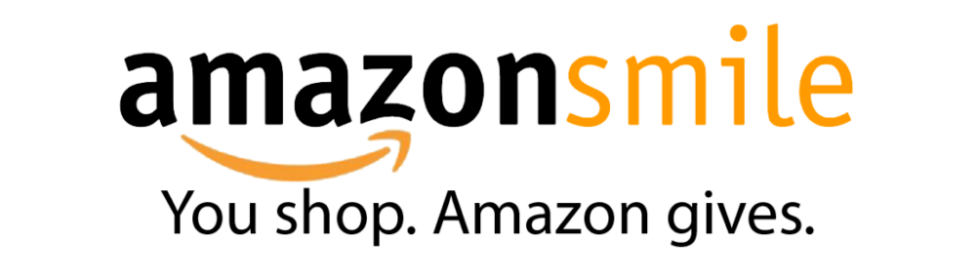
Similar to the Dillons Community Rewards program, Amazon Smile is a way for a percentage of your purchases on Amazon to go towards a charity of your choosing. St. Mary’s can benefit by your normal shopping on Amazon.

How to begin helping St. Mary’s
- Go to smile.amazon.com
- Click on “Sign in” in the upper right corner
- Enter your email or phone number associated with your amazon account
- Choose your charity of choice: St. Mary’s Catholic Church Newton
- You can add a bookmark on your web browser to smile.amazon.com
  - When shopping, for your purchase to count towards St. Mary’s, you must see “Supporting: St. Mary’s Catholic Church” at the top of your screen
- On your phone, activate Amazon Smile in the Amazon Shopping app within Settings or Programs & Features

Below is a link to a video that explains how set up Amazon Smile:
https://www.youtube.com/watch?v=VyJ7HcreC7A

